corn planter 1,500 2 row corn planter 700
2 row corn planter $300 450 corn planter for sale 350
4 row corn planter 30 planting corn 3,100
planting sweet corn 600
corn planting 300 peanut planter 150

planter peanut 90 bean planter 80
soy bean planter 30 bean planter for sale 20
green bean planter 20 soy bean planting 500
planting bean seeds 150 planting green bean seeds 90
peanut plant 17,000 peanut seeds for planting 150
peanut planting 30
1100 sets hand-operated corn peanut planter machine have been delivered to Nigeria
March, a blossom season, is also an exciting month for us, and 1100 sets peanut plant machines have been delivered to Nigeria! We put great efforts to produce such a great amount of planters and all was finished within one month. Having cooperated many times, this customer directly placed order from us without any hesitation. Unlike other customers who visit our factory to confirm such things as the quality of planting corn, the performance during operation and the capacity etc., he trusted us very much and ordered machine when he has any needs.
Due to limited space of container, the spare part of machine needs to be disassembled when packing, therefore, it is necessary to pack small screws in the bag, which means the screw on soy bean planting should be removed and users can install them individually when they receive machine.
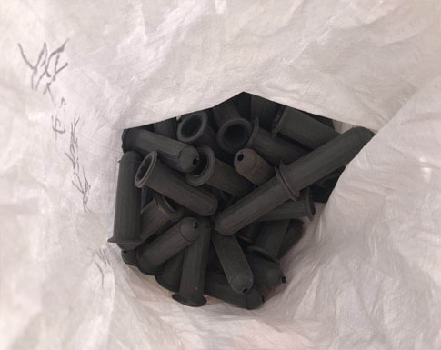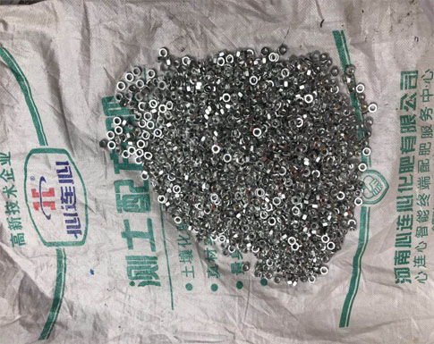
The following pictures are the packing details.
It is the corn planting before packing, mainly consisting of feeding hopper, a big wheel, two handles, soil digger, soil cover and seed sowing device, and can be used for many crops. Thus, this is a multi-purpose planter for farmers.

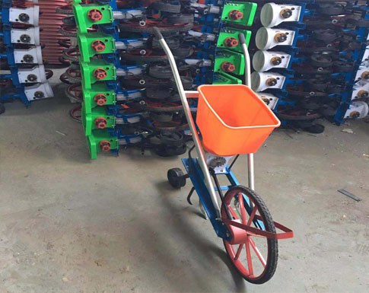
Our workers worked hard to place the machines into container, and some spare parts should be packed by film.
You may wonder why this customer orders great quantities of corn planter from us? I will give you an answer.
Firstly, this planter machine has multiple functions, and the raw material can be peanut, wheat, and corn, which can be achieved by changing seed-sowing device inside machine.
Secondly, machine is easy to work. It needs two people during operation. One pulls the belt that connects the front wheel and another pushes the machine to move forward.
Thirdly, peanut planter machine is equipped with high working efficiency,and the revival rate of crop is also high.
Most important, we are factory direct sale and the price of machine is rather low.
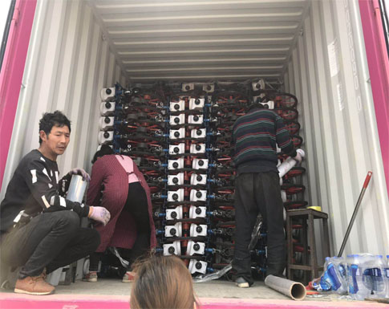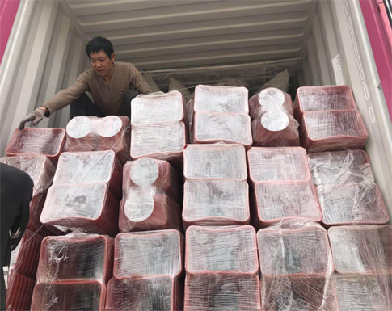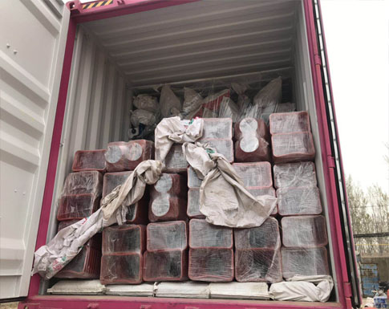
The following two pictures are the feedback of our customers, and they said that they liked this machine very much, highly praising the quality of bean planter.
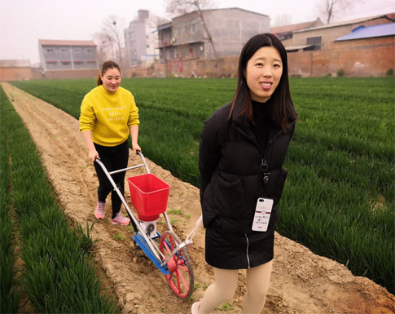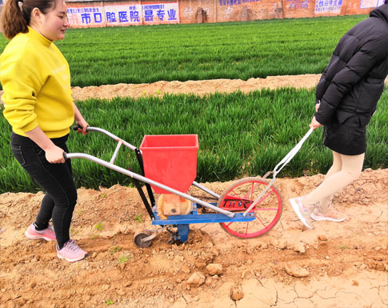
All in all, this peanut seeds for planting machine is equipped with stable performance and high working efficiency. It is a best choice for individual farmers, especially the farmers living in an underdeveloped country. We have perfect after-sale service and 24h online-service, and our aim is to make every customer satisfied whatever you are a farmer or dealer.
Please click the following link to view other types of planter machine if you are interested.

